Social media post Report

1. Introduction
2. A Social media post is a short from tyee of content or message that gets published on social media platforms.
3. Twitter, linkedin and other similar channel
4. Advantages and Disadvantages
   1. Social media usage also helps you build your brand because it enables sharing . You can share retweet and repin content on theses platform
5. Disadvantages
   1. Spending a lot of time on social media
   2. Fake news
   3. Content on social media is not appropriate for Children
6. Application
   1. Every web based applications that support information published and sharing ( text, video, audio, photo)
7. Conclusion

The effects from social media are very complex and very from person to person.

1. Future scope
   1. Social Media will be more integrated into personal social and business lives.
2. Appendix

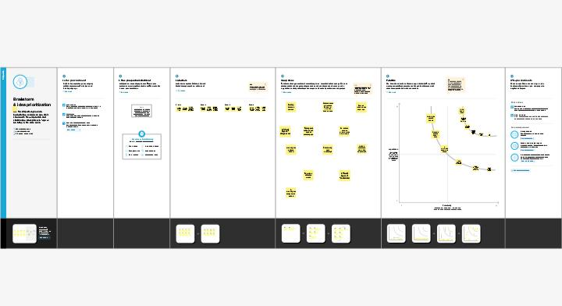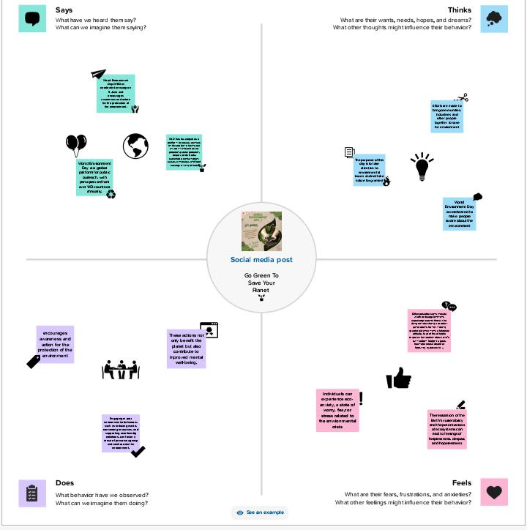The advice on the general use of social media in this appendix comes from case example interview and from the national association of state chief information officers